select ename, Job, deptno from emp where job='CLERK'

select ename, Job, deptno from emp where ename='JAMES'

select ename,sal,comm from emp where sal<=comm;

select ename, sal from emp where sal between 1000 and 1500

select empno, ename,sal,mgr from emp where mgr in(7902,7566,7788)

select ename from emp where ename like 'S%'

select ename from emp where ename like '_A%'

select ename, mgr from emp where mgr is null

select empno,ename,job,sal from emp where sal>=1100 and job='CLERK'

SELECT ENAME,JOB FROM EMP WHERE JOB NOT IN ('CLERK','MANAGER','ANALYST')

SELECT ENAME,JOB,SAL FROM EMP WHERE (JOB='SALESMMAN' OR JOB='PRESIDENT') AND SAL>1500

SELECT ENAME, JOB, SAL FROM EMP WHERE JOB='SALESMAN' OR JOB='PRESIDENT' AND SAL>1500

SELECT ENAME, JOB, DEPTNO, HIREDATE FROM EMP ORDER BY HIREDATE;

select ename,job,deptno,hiredate from emp order by hiredate desc;

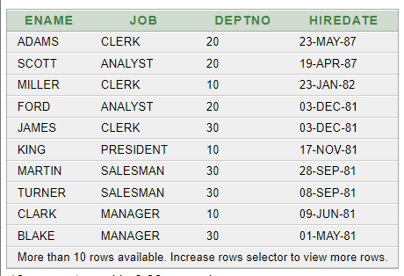

select empno, ename, sal*12 annsal from emp order by annsal;

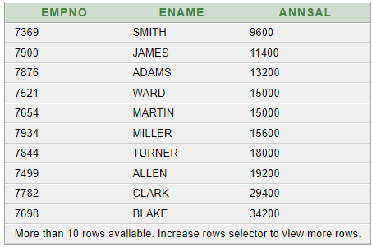

select ename,deptno, sal from emp order by deptno, sal desc;

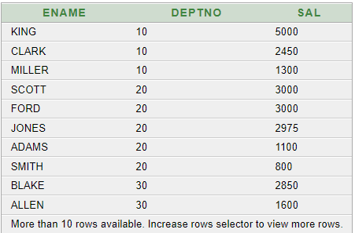

select ename , concat (ename,job ), length(ename), instr(ename,'A') from emp WHERE substr(job,1,5)='SALES';

select round(45.923,2), round(45.923,0), round(45.923,-1) from dual;



select trunc(45.923,2), trunc(45.923),trunc(45.923,-1) from dual;



select ename,sal,comm,mod(sal,comm) from emp where job='SALESMAN';

select to_char(sal,'$99,999') salary from emp where ename='SCOTT';

select ename ,sal,comm, (sal*12)+nvl(comm,0) from emp;

select job,sal,decode(job,'ANALYST', sal*1.1, 'CLERK', sal*1.15,'MANAGER', sal*1.20, sal) revised_salary from emp;

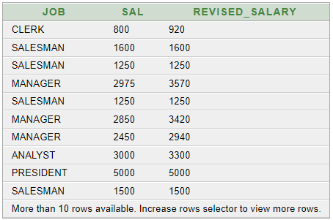

select ename, nvl(to_char(mgr),'No Manager') from emp where mgr is null;



select avg(sal), max(sal),min(sal),sum(sal) from emp where job like'SALES%'; 

select min(hiredate), max (hiredate) from emp;



select count(*) from emp where deptno=30;



select count (comm) from emp where deptno =30;



select avg(comm) from emp;



select deptno , avg (sal) from emp group by deptno;

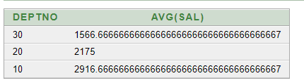

select avg (sal) from emp group by deptno;

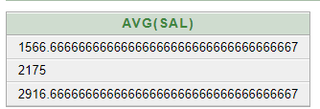

select deptno, job,sum(sal) from emp group by deptno, job;

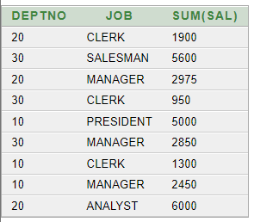

select deptno ,max (sal) from emp group by deptno having max (sal) >2900;

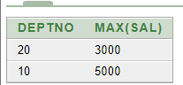

select job , sum(sal) payroll from emp where job not like 'SALES%' group by job having sum(sal)>5000 order by sum(sal);

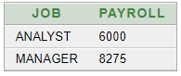

select max (avg(sal)) from emp group by deptno;

